**Project 2: Hotel Reservation Analysis with SQL**

In this Project, we will use SQL to answer the questions related to dataset. This will help us to develop our data analysis skills in a practical context.

**Overview:**

The hotel industry relies on data to make informed decisions and provide a better guest experience. In this internship, you will work with a hotel reservation dataset to gain insights into guest preferences, booking trends, and other key factors that impact the hotel's operations. We will use SQL to query and analyze the data, as well as answer specific questions about the dataset.

**Dataset Details:**

The dataset includes the following columns:

* **Booking_ID:** A unique identifier for each hotel reservation.
* **no_of_adults:** The number of adults in the reservation.
* **no_of_children:** The number of children in the reservation.
* **no_of_weekend_nights:** The number of nights in the reservation that fall on weekends.
* **no_of_week_nights:** The number of nights in the reservation that fall on weekdays
* **type_of_meal_plan:** The meal plan chosen by the guests.
* **room_type_reserved:** The type of room reserved by the guests.
* **lead_time:** The number of days between booking and arrival.
* **arrival_date:** The date of arrival.
* **market_segment_type:** The market segment to which the reservation belongs.
* **avg_price_per_room:** The average price per room in the reservation.
* **booking_status:** The status of the booking.

**Queries:**

**1. What is the total number of reservations in the dataset?**

SELECT COUNT(Booking_ID) AS Total_Reservation

FROM Hotel_Reservation;

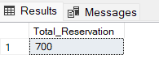

**Insights: -** Understanding the total number of reservations provides an overview of the dataset's size and the hotel's overall booking volume.

**2. Which meal plan is the most popular among guests?**

SELECT TOP 1 type_of_meal_plan, COUNT(type_of_meal_plan) AS Reservation_Count

FROM Hotel_Reservation

GROUP BY type_of_meal_plan

ORDER BY Reservation_Count DESC;

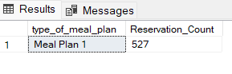

**Insights: -** Identifying the most popular meal plan among guests helps the hotel understand guest preferences and tailor their offerings accordingly.

**3. What is the average price per room for reservations involving children?**

SELECT AVG(avg_price_per_room) AS Average_Price_For_Reservations_With_Children

FROM Hotel_Reservation

WHERE no_of_children>0

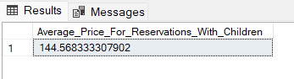

**Insights: -** Calculating the average price per room for reservations involving children can help the hotel set pricing strategies and package deals for families.

**4. How many reservations were made for the year 20XX (replace XX with the desired year)?**

SELECT COUNT(Booking_ID) AS Total_Reservations_For_2018

FROM Hotel_Reservation

WHERE YEAR(arrival_date) = '2018';

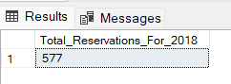

**Insights: -** Analyzing reservations made for a particular year helps in understanding booking trends over time and aids in forecasting future demand.

**5. What is the most commonly booked room type?**

SELECT TOP 1 room_type_reserved, COUNT(room_type_reserved) AS Reservation_counts

FROM Hotel_Reservation

GROUP BY room_type_reserved

ORDER BY Reservation_counts DESC;

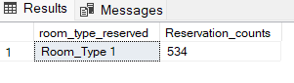

**Insights: -** Knowing the most commonly booked room type allows the hotel to optimize room allocation and potentially adjust room rates based on demand.

**6. How many reservations fall on a weekend (no_of_weekend_nights > 0)?**

SELECT COUNT(Booking_ID) AS Total_Weedkend_Reservations

FROM Hotel_Reservation

WHERE no_of_weekend_nights>0;

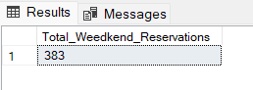

**Insights: -** Identifying the number of reservations that fall on weekends provides insights into peak booking periods, allowing the hotel to plan staffing and resources accordingly.

**7. What is the highest and lowest lead time for reservations?**

SELECT MAX(lead_time) AS Highest_lead_time,

MIN(lead_time) AS Lowest_Lead_Time

FROM Hotel_Reservation;

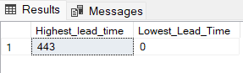

**Insights: -** Understanding the highest and lowest lead times for reservations helps the hotel manage inventory and optimize revenue management strategies.

**8. What is the most common market segment type for reservations?**

SELECT TOP 1 market_segment_type, COUNT(market_segment_type) AS Segment_Count

FROM Hotel_Reservation

GROUP BY market_segment_type

ORDER BY Segment_Count DESC;

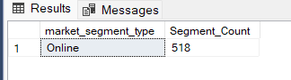

**Insights: -** Knowing the most common market segment type for reservations enables the hotel to tailor marketing efforts and services to specific customer segments.

**9. How many reservations have a booking status of "Confirmed"?**

SELECT COUNT(Booking_ID) AS Confirmed_Reservations

FROM Hotel_Reservation

WHERE booking_status = 'Not_Canceled';

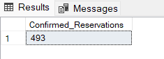

**Insights: -** Tracking the number of confirmed reservations helps in assessing booking conversion rates and forecasting revenue more accurately.

**10. What is the total number of adults and children across all reservations?**

SELECT SUM(no_of_adults) AS Total_Adults,

SUM(no_of_children) AS Total_Children

FROM Hotel_Reservation;

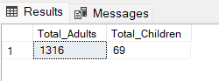

**Insights: -** Understanding the total number of adults and children across all reservations provides insights into the hotel's guest demographics and helps in resource planning.

**11. What is the average number of weekend nights for reservations involving children?**

SELECT AVG(no_of_weekend_nights) AS Average_Weekend_Nights_For_Reservation_With_Children

FROM Hotel_Reservation

WHERE no_of_children > 0;

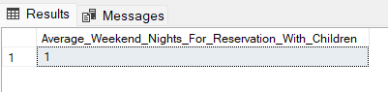

**Insights: -** Calculating the average number of weekend nights for reservations involving children helps the hotel understand family travel patterns and tailor offerings accordingly.

**12. How many reservations were made in each month of the year?**

SELECT COUNT(Booking_ID) AS Reservation_by_each_Month,

MONTH(arrival_date) AS MonthNumber,

DATENAME(MONTH, arrival_date) AS MonthName

FROM Hotel_Reservation

GROUP BY MONTH(arrival_date), DATENAME(MONTH, arrival_date)

ORDER BY MonthNumber;

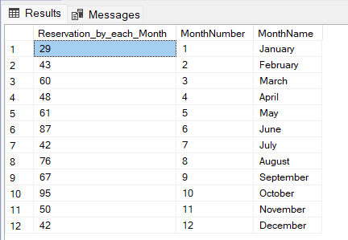

**Insights: -** Analyzing reservations made in each month of the year reveals seasonal booking patterns, which can inform pricing strategies and marketing campaigns.

**13. What is the average number of nights (both weekend and weekday) spent by guests for each room type?**

SELECT room_type_reserved, AVG(no_of_weekend_nights) AS Average_Weekend_Nights,

AVG(no_of_week_nights) AS Average_Weekday_Nights,

AVG(no_of_weekend_nights + no_of_week_nights) AS AvgNightsPerRoomType

FROM Hotel_Reservation

GROUP BY room_type_reserved;

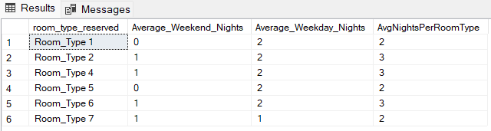

**Insights: -** Understanding the average number of nights spent by guests for each room type helps in optimizing room inventory and pricing strategies.

**14. For reservations involving children, what is the most common room type, and what is the average price for that room type?**

SELECT TOP 1 room_type_reserved, AVG(avg_price_per_room) AS Average_Price

FROM Hotel_Reservation

WHERE no_of_children > 0

GROUP BY room_type_reserved

ORDER BY COUNT(room_type_reserved) DESC;



**Insights: -** Identifying the most common room type for reservations involving children helps the hotel allocate rooms effectively and potentially adjust room rates for family-friendly accommodations.

**15. Find the market segment type that generates the highest average price per room.**

SELECT TOP 1 market_segment_type, AVG(avg_price_per_room) AS AvgPricePerRoom

FROM Hotel_Reservation

GROUP BY market_segment_type

ORDER BY AvgPricePerRoom DESC;

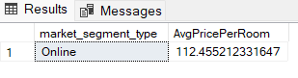

**Insights: -** Finding the market segment type that generates the highest average price per room allows the hotel to focus on high-value customer segments and tailor services to meet their needs.

**SUMMARIZED CONCLUSIONS:**

Based on the analysis of the hotel reservation dataset, the following summarized conclusions can be drawn:

* There are a total of 700 reservations in the dataset.
* Meal Plan 1 is the most popular among guests, with 527 out of 700 reservations opting for this meal plan.
* The average price per room for reservations involving children is $144.56.
* In the year 2018, there were 577 reservations made.
* Room-Type 1 is the most commonly booked room type, with 534 out of 700 reservations choosing this option.
* There are 383 reservations that fall on weekends.
* The highest lead time for a reservation is 443 days, while the lowest is 0 days.
* The online market segment type accounts for the highest number of reservations, with about 518 reservations made through this segment.
* There are 493 reservations with a booking status of "Confirmed."
* There are 1316 adults and 69 children across all reservations.
* The maximum number of reservations occurred in October (95), followed by June (87) and August (76).
* The online market segment type generates the highest average price per room, which is $112.45.